***Problem: Interconnection between two systems.***

***Source code:***

|  |  |
| --- | --- |
|  | **clc;**  **clear all;**  **close all;**  **th1 = 0 : .01 :3;**  **th2 = 0 : .01 :3;**  **th22 = 3.01: .01 : 6;**  **h1 = th1 .* exp(-3*th1);**  **tx = 0 : .01:3;**  **%first system**  **x = ones(size(tx));**  **w = conv(x,h1) .* .01;**  **tw = linspace(min(tx)+ min(th1),max(tx)+ max(th1),length(w));**  **h2 = [th2 .* cos(pi .* th2) zeros(size(th22))];**  **y = conv(w,h2) .* .01;**  **ty = linspace(min(th2)+ min(tw),max(th2)+ max(tw),length(y));**  **figure**  **plot(ty,y,'r');**  **%second system**  **h2 = th2 .* cos(pi .* th2) ;**  **w2 = conv(h1, h2) ;**  **tw = linspace(min(th2)+ min(tw),max(th2)+ max(tw),length(w2));**  **x2 = [x zeros(size(th22))];**  **tx2 = [tx th22];**  **y2 = conv(x2,w2) ;**  **ty2 = linspace(min(tx2)+ min(tw),max(tx2)+ max(tw),length(y2));**  **figure**  **plot(ty2,y2,'b');** |
| **Output:** | |

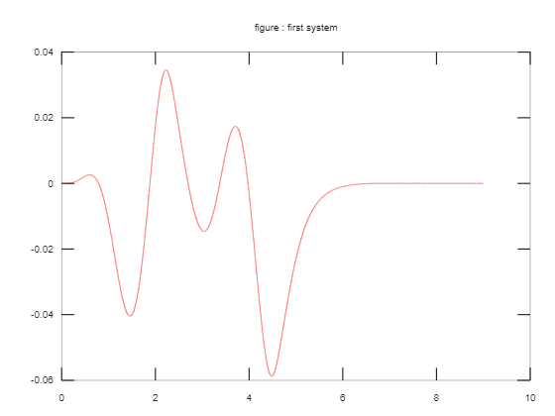

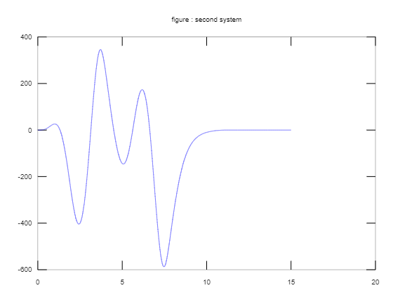

***Problem: Differential Equation With degree one (Y)***

***Source code:***

|  |  |
| --- | --- |
|  | **clc;**  **close all;**  **clear all;**  **f = 'Dy + y - cos(t)';**  **y = dsolve(f, 'y(0) = 2');**  **ezplot(y,[1 20])** |
| **Output:** | |

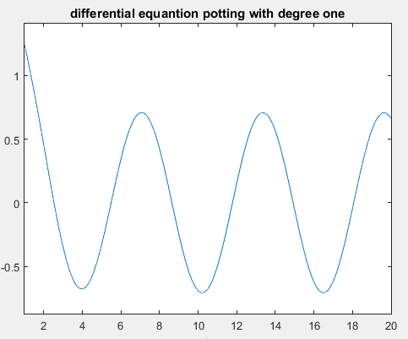

***Problem: Differential Equation With degree two (Y’)***

***Source code:***

|  |  |
| --- | --- |
|  | **clc;**  **close all;**  **clear all;**  **f = '2*D2y+Dy+y-Dcos(t)';**  **y = dsolve(f,'y(0)=2');**  **ezplot(y,[0 20])** |
|  | |
| **Output:** | |

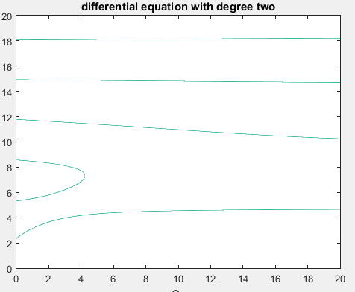

***Problem: Solving and Plotting Difference Equation***

***Source code:***

|  |  |
| --- | --- |
|  | **clc;**  **close all;**  **clear all;**  **b = [.067 .1349 .675];**  **a = [1 -1.143 .4128];**  **n = 1:20;**  **x = (.5).^n;**  **zi = filtic(b,a,[1 2]);**  **y = filter(b,a,x,zi);**  **stem(n,y)** |
| **Output:** | |

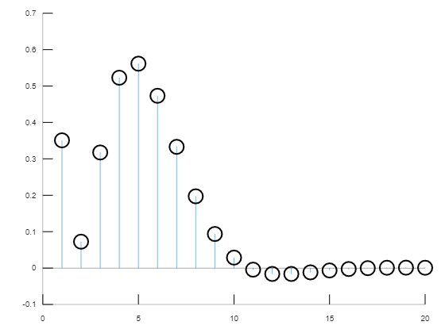

***Problem: Solving and Plotting Fourier series Equation (1)***

***Source code:***

|  |  |
| --- | --- |
|  | **clc;**  **close all;**  **clear all;**  **T0 = 1;**  **E = 1;**  **w0 = 2*pi;**  **a0 = E/2;**  **n = 5000;**  **f = a0/2;**  **t = -1.5:.01:1.5;**  **for N=1:n**  **an = ((2*E)/(T0*w0*N) * sin(N*pi/2) - sin(3*N*pi/2));**  **f = f+ an*cos(N*w0*t);**  **end**  **plot(t,f,'r')** |
| **Output:** | |

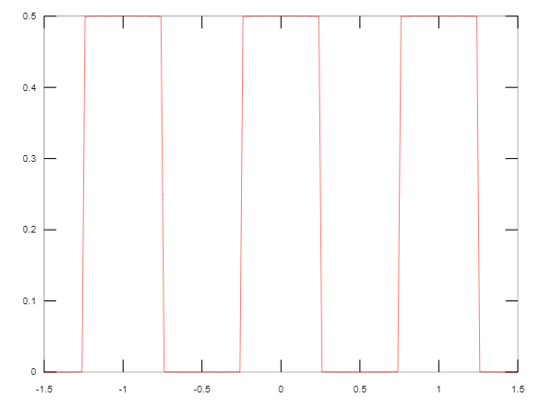

***Problem: Solving and Plotting Fourier series Equation (2)***

***Source code:***

|  |  |
| --- | --- |
|  | **clc;**  **close all;**  **clear all;**  **T0 = 2*pi;**  **E = 1;**  **w0 = 1;**  **a0 = E/2;**  **n = 5000;**  **f = a0;**  **t = -10:.01:10;**  **for N=1:n**  **bn = (-1/2*pi.^2) * (2*pi*cos(2*pi*N)/N + cos(2*pi*N)/N - 1/N) ;**  **f = f+ bn*sin(N*w0*t);**  **end**  **plot(t,f,'r')** |
| **Output:** | |

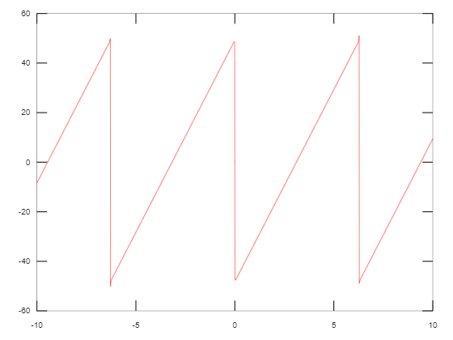

**© Mohsin_riad**